Chapter 16, Solution 10.
The step responses of a series RLC circuit are

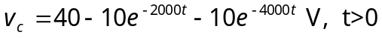
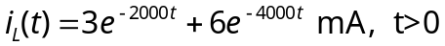

- Find C. (b) Determine what type of damping exhibited by the circuit.

Solution

(a) 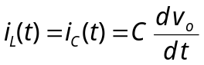 (1)

(2)

But 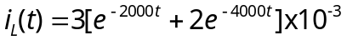 (3)
Substituting (2) and (3) into (1), we get

(b) Since s₁ = - 2000 and s₂ = - 4000 are real and negative, it is an overdamped case.

